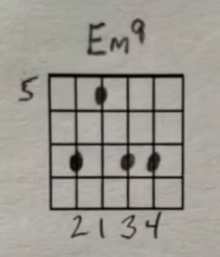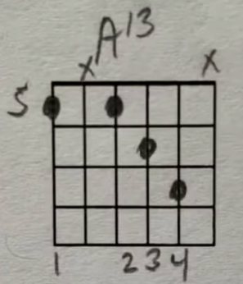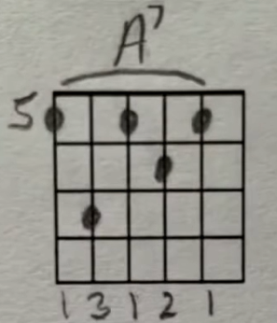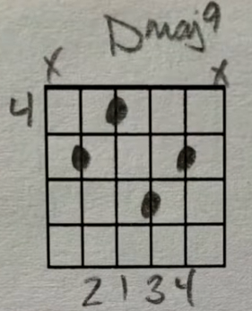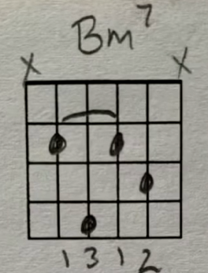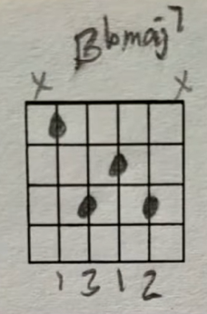

Em9 – DDUDDX

A13 – DDUD

A7 – DX

Dmaj9 – DDUDDX

Bm7 – D (Hammer-On Fingers 1,2) DU

Bbmaj7 – D

Harmonics

Em9 – DDUDDX

A13 – DDUD

A7 – D

Riff

Dmaj9 – DDUDDX

Bm7 – D (Hammer-On Fingers 1,2) DU

Bbmaj7 – D

Harmonics